**NAD Completion:**

To check the NAD completion for the site/pvc/order, follow this URL path to LPP.

<http://icoreweb.noc.att.com:5020/servlet/Client.OrderMgmt.SearchOrderMgmt?ENTITY=Order&SCREENTITLE=Order+Management+Search>

Enter the ICORE PVC ID or other detail if you have and search:

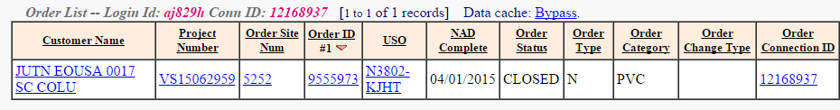

If the NAD completion date is posted and order status is CLOSED, then the order is NAD Completed.

**AVPN Activities:**

To check the AVPN activities, follow the same path and search either through ICORE PVC ID, ICORE SITE ID or USRP Order #

If you do not have USRP Order # , then you can search by icore_pvc_id thru ICORE GUI And you will get USRP Project # there.

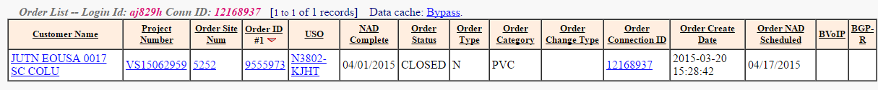

Then open that USRP Order # in QSOTS:

<http://usrp.web.att.com:8008/cgi-bin/query_so_status>

Open the order in this tool and check for AISE status.

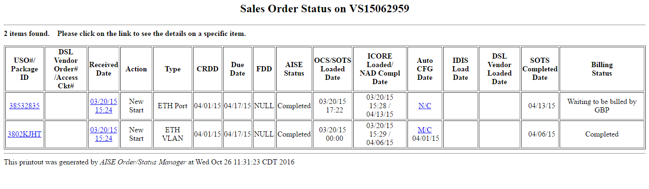

If AISE status is “Completed”, then AVPN activities are marked completed in USRP.

**BVOIP Indicator:**

To check the BVOIP indicator, you need to search ICORE through ICORE PVC ID:

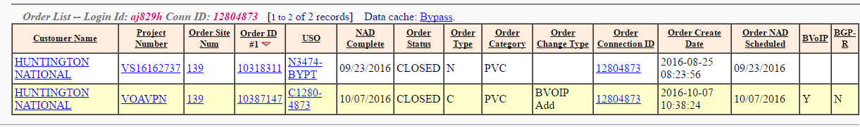

You need to check for the order type in ICORE and event in EFMS and check the BVOIP indicator correspondingly.

In the above example BVOIP is added and BVOIP indicator is set to “Y” so BVOIP is added to the connection.

**NOTE:** The BVOIP order identified through “VOAVPN” should always be NAD completed. If the BVOIP order is NAD completed then only you can say, BVOIP is added or delete from ICORE.

Sometimes the BVOIP order is not created in ICORE or if created then it’s not NAD completed, then you can check for the error in USRP thru Arthur:

<http://d2usr1w1.vci.att.com:8008/cgi-bin/arthur/do_sql_pl.pl>

select * from pvc_feature_config where pvc_id= (icore_pvc_id)

Check for bvoip_config_error_reason corresponding to event_type.

For example:

select entered_date_time,pvc_id,bvoip_config_error_reason,event_type from pvc_feature_config where pvc_id=12738067

|  |  |  |  |  |
| --- | --- | --- | --- | --- |
| ***Count*** | **entered_date_time** | **pvc_id** | **bvoip_config_error_reason** | **event_type** |
| 1 | Aug 24 2016 12:19PM | 12738067 | Cannot create order - An OPEN NEW PVC Order exists | ConnectBVOIP |